[ART B
The purpose of this assignment is to explain core concepts related to stocks and to analyze the ethical implications of decisions and promote ethical standards within organizations.
Read the Chapter 7 Mini Case on pages 339-341 in Financial Management: Theory and Practice. Using complete sentences and academic vocabulary, please answer questions a through d.
Using the mini case information, write a 250-500 word report presenting potential ethical issues that may arise from expanding into other related fields. In your discussion, proactively strategize about possible expansion by explaining opportunities to promote ethical standards within your organization.

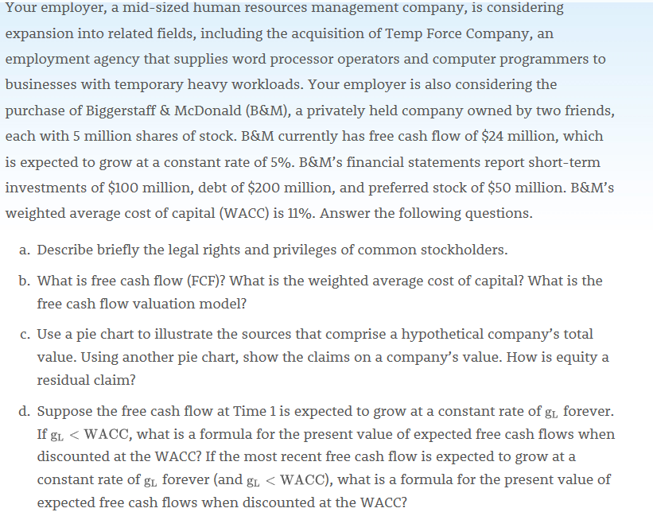
- Common shareholders have been bestowed with several legal rights and privileges which they enjoy. These rights and privileges include electing of the firm’s director and authority to purchase additional shares. Traditionary, common share holders have more privileges compared to their counterparts. They can be elected or participate in electing firm’s directors.
- Free cash flow (FCF) is the cash flow available for distribution to all of a company’s investors. FCF is generated by a company’s operations.
Solution
Free cash flow of the firm will be = 24,000,000* (1+0.05) / (0.11 – 0.05) = 420 Million
Debt = 200 Million, Preferred stock of $50 million.
Therefore, FCFE = 420M – 200M – 50M = $170M

The weighted average cost of capital (WACC) is the overall rate of return required by all of the company’s investors. The PV of their expected future free cash flows, discounted at the WACC, is the value of operations. This is the essence of the FCF valuation model.
Nonoperating assets are marketable securities and ownership of non-controlling interest in another company. The value of nonoperating assets usually is very close to figure that is reported on balance sheets.
- Total corporate value is sum of value of operations and value of nonoperating assets. Some company’s also have growth options, but assume they are negligible for this company. Debtholders have first claim. Preferred stockholders have the next claim. Any remaining value belongs to stockholders.

Equity residual claim = 29%

- Formula for the present value of expected free cash
$V_{op}=\frac{{FCF}_{1}}{WACC- g_{L}}$
Present value of expected free cash flows when discounted at the WACC

$V_{op}=\frac{{FCF}_{0}(1+g_{L})}{WACC- g_{L}}$

Report on potential ethical issues
Expansion is a strategy that is adopted by the fast growing organizations. This may be due to increased productivity and the desire to tap new markets. A well calculated expansion move can work well to the benefit of the entire organization. However, due to poor planning and lack of proper expansion mechanisms, business expansion can be detrimental to the organizational undertakings. Notably, despite the expansion goals to tap new markets, the move may be detrimental to the employers and employees on the same measure. Poor planning may result to inadequate resources, workers being subjected to long working hours and poor working conditions. Consequently, due to poor working environment, the quality of the service provided may go down with employees becoming demotivated. They develop laxity culture and do not employ innovative skills in their undertakings.
Additionally, in the process of expansion, there might be a clash between the management and the regulatory authorities. In such a situation, the management might be tempted to pay some amount of money to seek some favor from the authorities. Interestingly the amount paid is not stipulated on the regulatory framework but it’s aimed to seek for some unmerited favor which amounts to corruption. Lastly, in most of the companies that discharge harmful substances to the environ, most of them ignore set pollution regulations and end up paying small token to authorities to be allowed to continue manufacturing processes.
Never the less, due to the benefits that are attributable to expansion such as increased market share, economies of scale and enhanced efficiency, it is important for the organizations to first strategize through evaluating their target clients. Additionally, well laid down policy on the recruitment processes, core values, mission and vision statement should clearly formulated and implemented. Additionally, in regards to pollution, it is wise for the organization to conduct health hazards evaluation and environment effect of their activities. If found that their activities will result in heavy pollution, proper mechanisms should be put in place to treat the waste before being discharged to the environment.

